

CA PPM v14.x

Benefits Calculation Guide  
Release 1.1

# Version History

|  |  |  |  |
| --- | --- | --- | --- |
| Author | Date | Version | Comments |
| Alexandre Assis | 28/Sep/2015 | 1.0 | * Initial Draft |
| Alexandre Assis | 20/Apr/2016 | 1.1 | * New Demo Data |

**Table of Contents**

1. Version History 2

2. Benefits Calculation - Guide 4

2.1. Introduction 4

2.2. How to use 4

# Benefits Calculation - Guide

## Introduction

Benefits Calculation is intended to help our customers Build Business Cases for Cost x Benefit Analysis using the CA PPM Investments objects (especially, but not limited to, Ideas, Projects and Programs).

## How to use

Basic steps to use this Accelerator:

1. Preparation:
   1. Map your project Types (example: New Store)
   2. For each Project Type, define the possible Benefits you will achieve by executing an investment of that Type (example: Increased Product Revenue) – and define a formula for each one (example: #Product Units Sold x Average Product Price)
2. Model the Benefits in CA PPM:
   1. Create your Benefit Variables.
   2. Create your Benefit Calculations.
   3. Create your Benefit Groups.
3. Use the Benefits Calculation Feature:
   1. Open an Investment (example: New Store on 5th Avenue)
   2. Navigate to Financial Plans, Benefit Plans
   3. Create a new Benefit Plan. (example: Initial Benefit Plan for 5th Avenue Store)
   4. On the Benefit Plan properties page you will assign a Benefit Group and a Benefit Plan Profile. (example: Group=Open New Store; Profile=”Most Likely”)

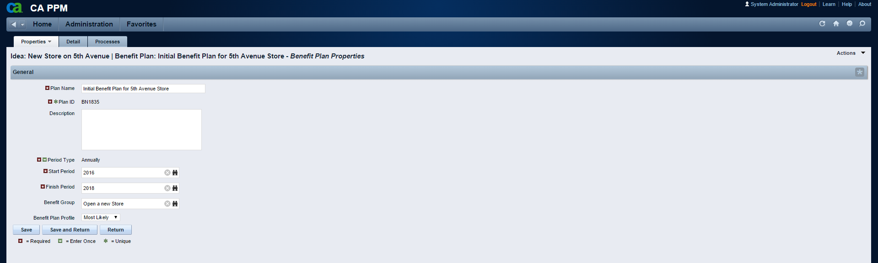

* 1. Using the Actions Menu, Initialize the Benefit Variables for your plan.
  2. Go to “Properties, Benefit Plan Variable List”
  3. Enter the values for your Investment-Driven[1] Variables (example: #Product Units Sold per Year = 10000)

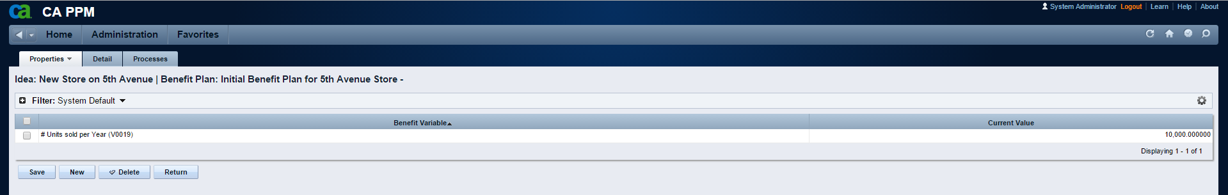

* 1. Go Back to “Properties, General”
  2. Using the Actions Menu, Generate or Update your Benefit Plan.
  3. Go to the “Details” tab
  4. Your Benefits have been calculated according to your Benefit Group and the values of the Variables you entered.

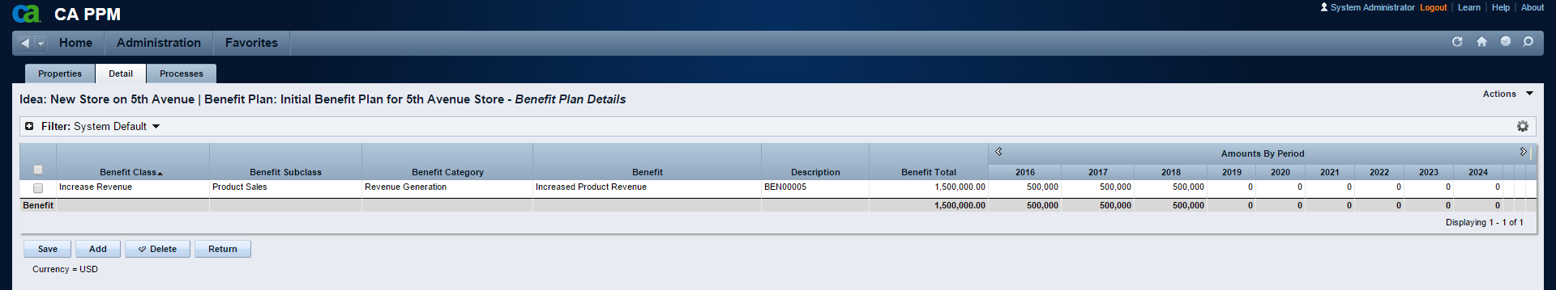

1. Benchmark-Driven variables are NOT carried over to the Benefit Plan. The Calculation process will take their values directly from the Benefit Variables object.